25FL-CS630-101HY - Database Systems- Final project -Library Management System:-
----Queries and execution in DBeaver:
----PLSQL script to generate multiple (1000)rows for Books table:-
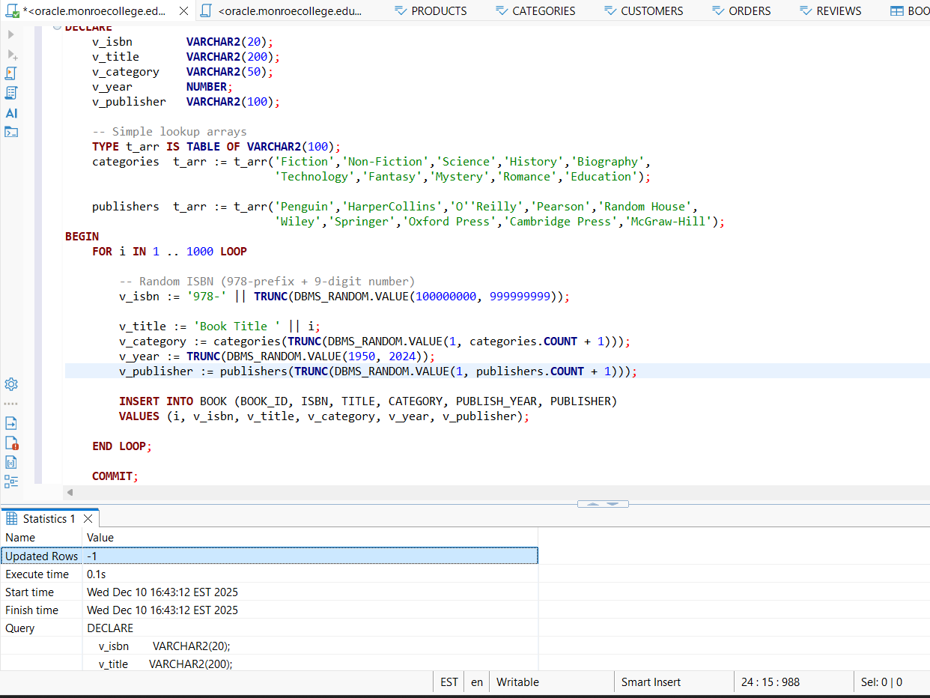

--Data in Book Table:- 1003 rows:
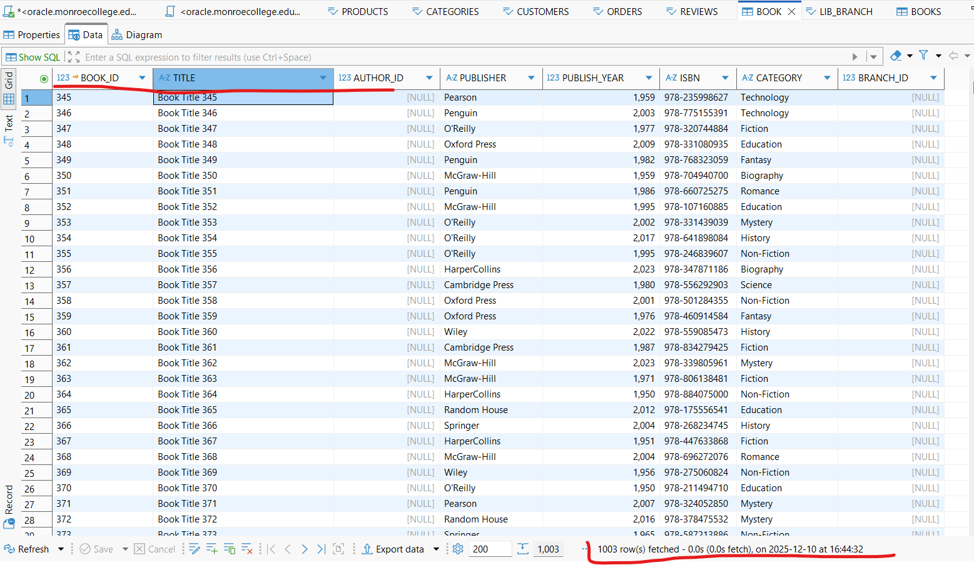
-----Simple error encountered while trying to insert similar values into LIB_BRANCH table as data was already present for BRANCH_IDs 1,2 and 3:-
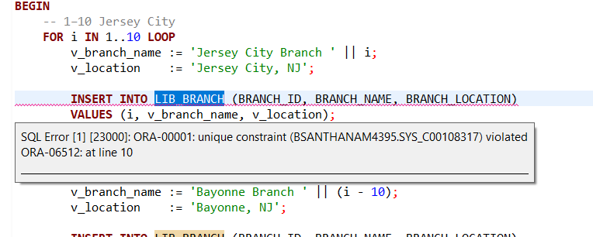

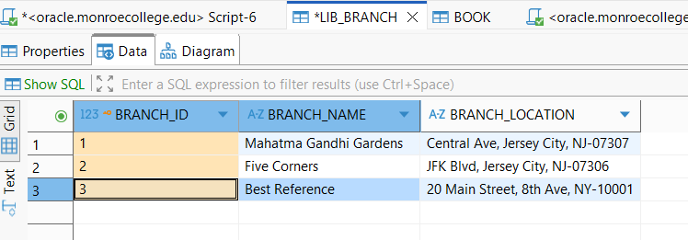
----Changed the BRANCH_ID values and now trying to insert using the PLSQL statement:
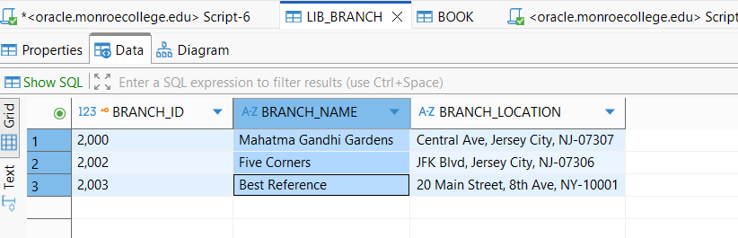
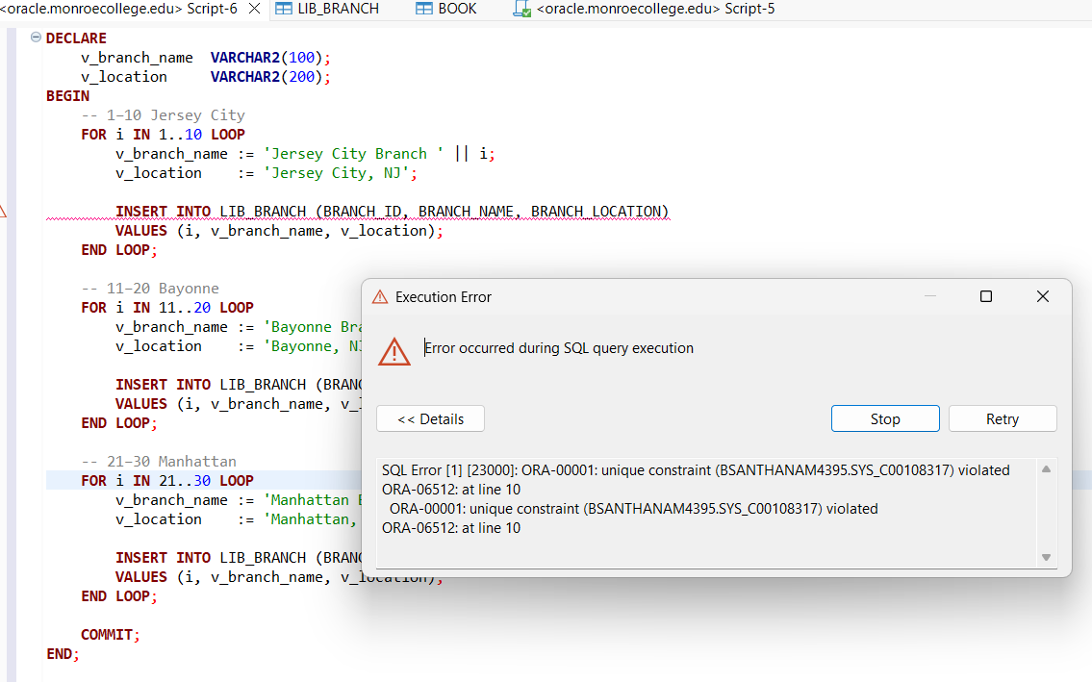
Still getting the error as there is a child row in BOOK table referring to this BRANCH_ID as a foreign key.
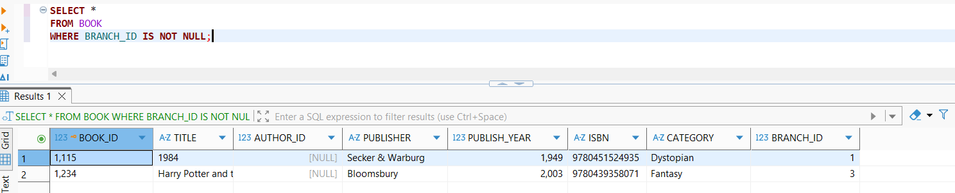
Now, updated the BOOK table to have NULL BRANCH_ID
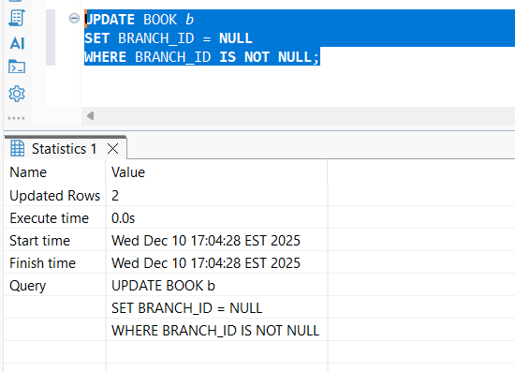
--After updating BOOK table:-
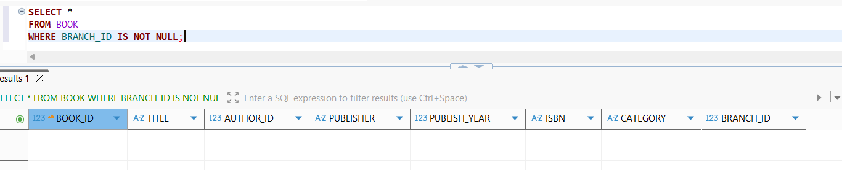
----While trying to update as NULL- as it is PRIMARY KEY and column cannot be NULL.
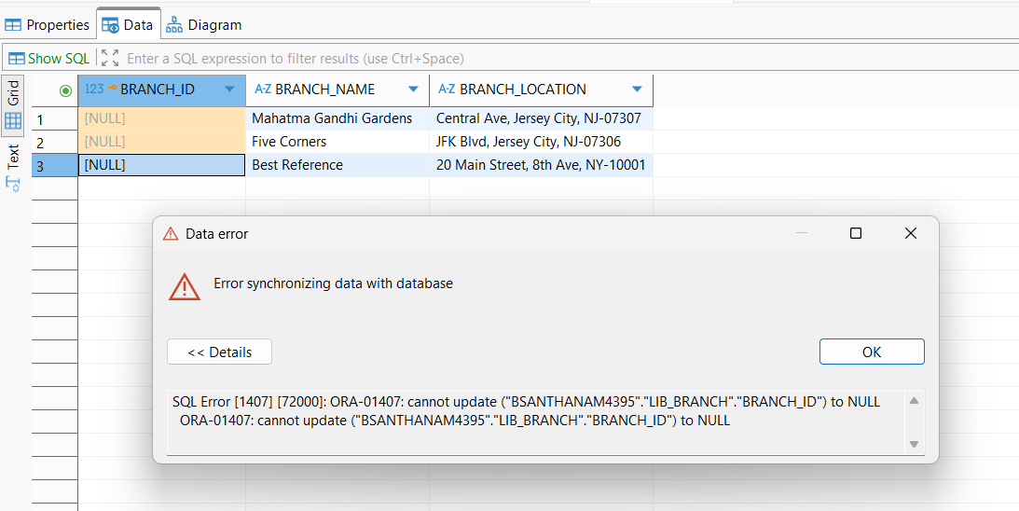
---Totally deleting the data and then trying to insert into the table:-
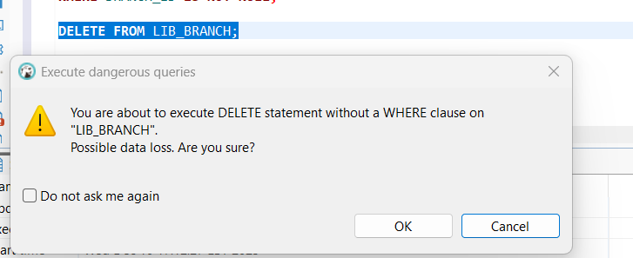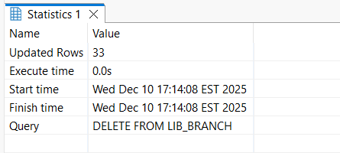
----Now inserted data into LIB_BRANCH table:-
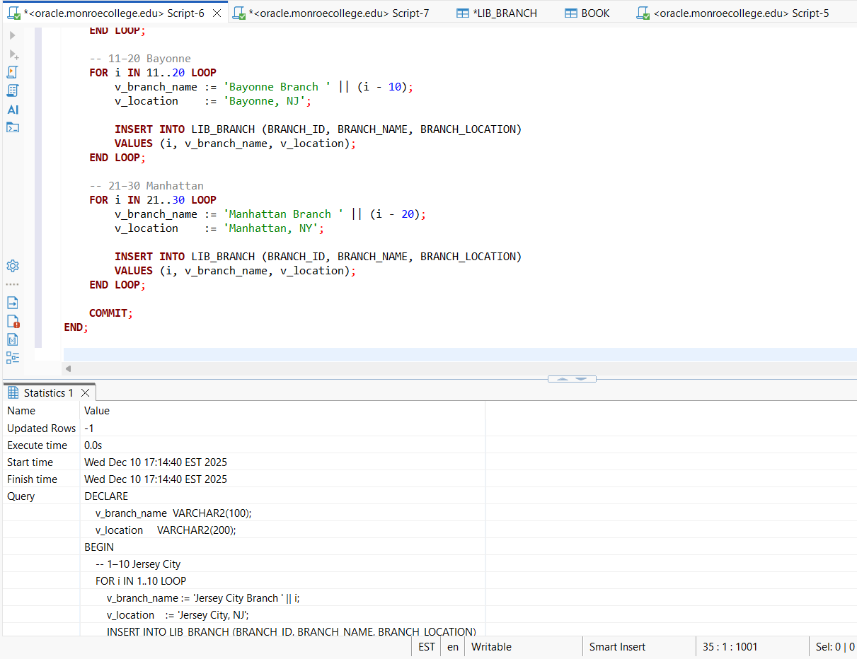
----Data in LIB_BRANCH table:- 33 rows
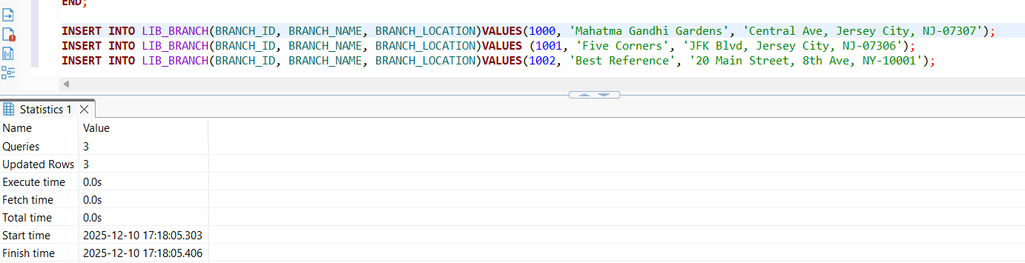
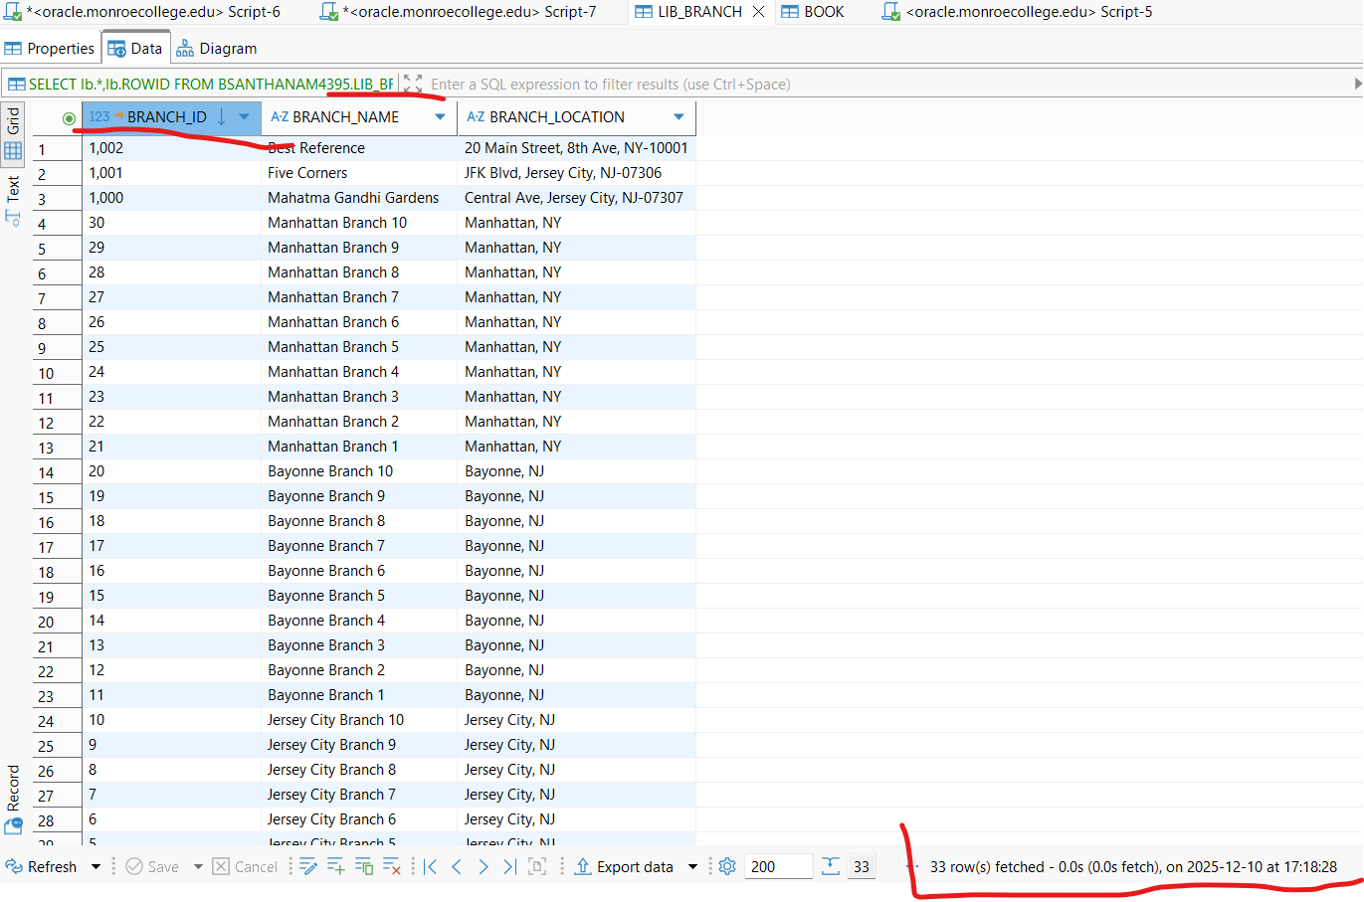
-----Updated BRANCH_ID in BOOK table:-
